**Supplementary Requirement Release 2**

1. FV - Field Validation Requirements

   1.1. Field “Credit Card Number”

**Scope:**

* UC03.01 Add Payment detail.
* UC03.02 Update payment details

**Requirements:**

* Field size should be fixed (15 or 16) number of digits.
* It should only contain numbers.
* Field is mandatory; System will not allow proceeding without a valid CC number.
* Field should accept only active credit cards.
* System should also show a popup window with an error message, “Please enter a valid Card Number” in case of invalid entry.

**Conditions to Apply:** After the respective join points.

1.2. Field “CC Security Code”

**Scope:**

* UC03.01 Add Payment detail
* UC03.02 Update payment details

**Requirements:**

* Field size should be fixed (3 or 4) number of digits.
* It should only contain numbers.
* Field is mandatory; System will not allow proceeding without a valid CC number.
* System should also show a popup window with an error message, “Please enter a valid CVV” in case of invalid entry.

1.3. Field “Expiration Month”

**Scope:**

* UC03.01 Add Payment detail
* UC03.02 Update payment details

**Requirements:**

* Field should appear in select field format.
* It should only contain numbers from 1 to 12.
* System should also show a popup window with an error message, “Please enter a valid Month” in case of invalid entry.

**Conditions to Apply:** After the respective join points

1.4. Field “Write a review…”

**Scope:**

* UC04.09 Add Rating/review.

**Requirements:**

* Field size should be fixed (25 or 30) number of characters.
* System should also show a popup window with an error message, “Please enter a valid Rating/review” in case of invalid entry.
* Field is mandatory; System will not allow proceeding without a valid Rating/reveiw.
* System should also show a popup window with an error message, “Please enter a valid Card Number” in case of invalid entry.

**Conditions to Apply:** After the respective join points.

1. CN – Connectivity

**Scope:**

* UC 02.02 Order Placement
* UC 03.01 Add Payment details.
* UC 03.02 Update payment details
* UC 04.09 Add Rating/review.

**Requirements:**

* System should retain caches to populate values, if the front-end is disconnected due to Network issue, or some error.
* System should also show a popup window with an error message, “Connection failed, please try again later”.

**Conditions to Apply:** After the respective join points.

1. DF-In – Data Flow IN

**Scope:**

* UC 02.02 Order Placement
* UC 03.02 Update payment details

**Requirements:**

* Order should contain the all the items added from cart .
* update payment details should contains all the add payment details.

**Conditions to Apply:** After the respective join points.

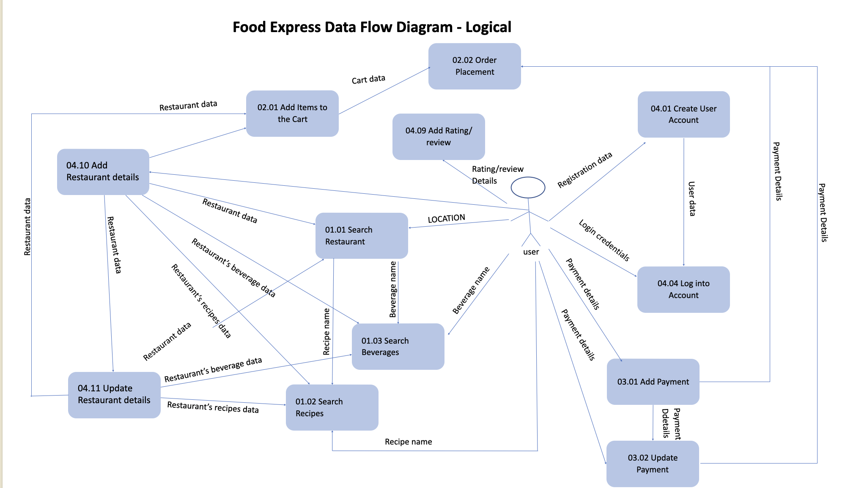

1. DF- Out- Data Flow Out

**Scope:**

* UC 03.01 Add Payment details.
* UC 03.02 Update payment details
* UC 04.09 Add Rating/review.

**Requirements:**

* All the added payment details should be saved in the database and displayed in update payment details.
* Updated payment details should be saved in the database and displayed in the Order Placement.
* Added Rating/review should be saved in the database and displayed in the existing order.

**Conditions to Apply:** After the respective join points.

